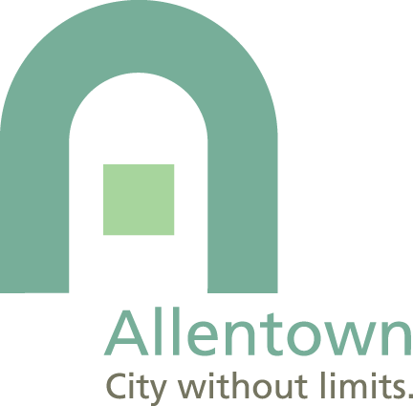
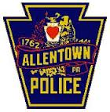
Allentown President’s Council

2016 Catch A Young Person
Doing Something Right
Nomination Form
Young people contribute to the well-being of this city in a number of ways. Please nominate a young individual, student, neighbor, friend, or family member who has demonstrated excellence or gone above and beyond the call of duty regardless of whom they’re around or who’s watching.
Nominations due by February 3, 2016

INSTRUCTIONS
Who is eligible?
- Eligible nominees include individuals in one of the three age groups: 7-10 years old; 11-14 years old; or 15- 18 years old.
- Group nominations are also welcomed. Please provide information about both the group and the individuals within the group. Specifically, please share a particular act of significance for each individual within the group, examples of shared responsibility and cooperation, and what the group has done to improve the City of Allentown.
- Individuals may not nominate themselves.
- Individuals may not be nominated by a family member.
- Nominees must live in Allentown or attend school in Allentown.
- Scholastic achievement nominations must be for an Allentown school.
- You are limited to one nomination please.
Certificates will be given in these categories
- Volunteerism – for assisting someone or improving a neighborhood or the community in general.
- Going Above and Beyond the Call of Duty – for doing more than following the rules, such as making a good decision even when peers chose otherwise. For showing leadership skills, critical thinking, problem solving, maturity or conflict resolution.
- Scholarship – Notable academic improvement and or academic excellence.
- NOTE – For example for the age group 7-10 – there will be an award for Volunteerism, Going Above and Beyond, and Scholarship.
Award Process
- Awards sponsored by the City of Allentown
- Nominations will be judged by a five person committee
- The nomination form must be complete. All instructions must be followed.
- NOTE – Nominees will be announced on February 5th on the city website. Award winners will be recognized at an awards ceremony to be held February 16, 2014.
Nomination Form
- NOMINEE (who are you nominating?) |  |  |  |  |  |  |  |  |  | - NOMINATOR (your contact information)
Name |  |  |  |  |  |  |  |  |  | Name
Age |  |  |  |  |  | Day Phone |  |  |  | Day Phone
Evening Phone |  |  |  |  |  |  |  |  |  | Evening Phone
Parents/Guardians |  |  |  |  |  |  |  |  |  | Title and Organization (if applicable)
Nominee Address |  |  |  |  |  |  |  |  |  | Address
City |  |  |  |  |  |  |  |  |  | City
Email |  |  |  |  |  |  |  |  |  | Email
School Name or School graduated from |  |  |  |  |  |  |  |  |  | Relationship to nominee
Deadline for Nominations: February 3, 2016
C. Award Category (Check one)
Volunteerism Going Over and Beyond the Call of Duty Scholastic Achievement

D. Narrative - Why should this young person receive an award? Consider telling us: What they have done, who they did it for, when they did it, what makes their scholarship special? Please share your remarks on the next page. If handwriting please write legibly or attach narrative
Please return the completed form to Mayor’s Office, 435 Hamilton Street, Allentown, PA 18101. or email ismael.arcelay@allentownpa.gov or fax at 610 437-8730. Questions? Call 610 437-7743

